LANDSCAPE PROJECT GCSE PHOTOGRAPHY

A01 - Select 2 landscape photographers that you like the style of, this can be of any landscapes i.e. countryside, beaches and parks, try to avoid cityscapes as this is covered in the mobile photography unit.
research the photographers and display some of their photographs on your website with analysis.

A02 - Take photographs in the style of these photographers.

Analyse your images

How can you change the photography to become your own style. – would you edit your pictures to explore A03 in more depth

Eventually you will progress to A04 – this will contain your strongest images – final edited piece

There are some landscape examples below

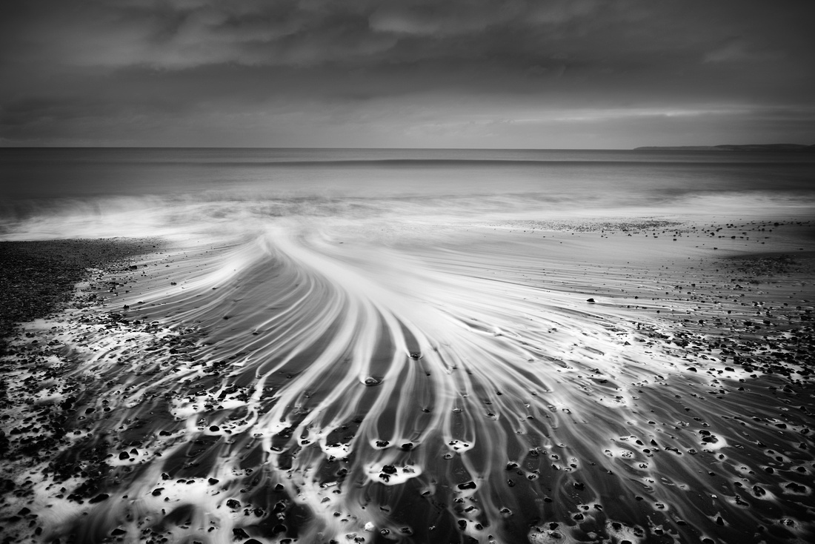

Russ Barnes

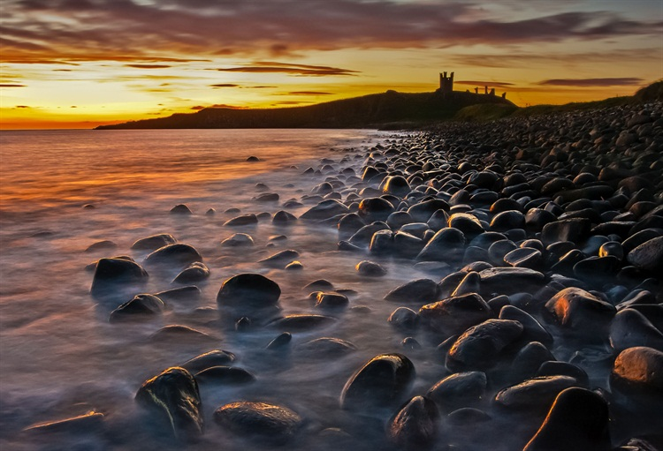

Tony Bennet

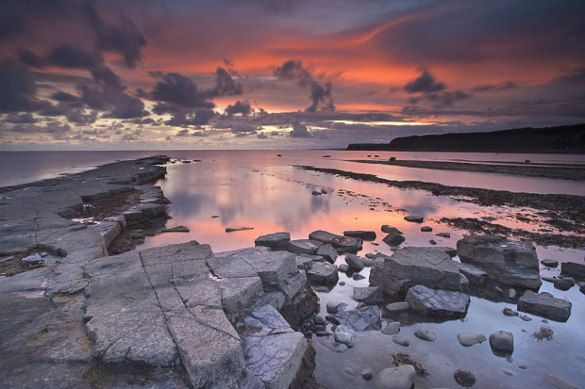

Antony Spencer

